Graph, DP. Normal
- [Graph] Roads Count
- [Graph] Find a ring road
- [Graph] Is there another country?
- [DP] The Fibonacci numbers
- [DP] Making change
- [DP] Maximum Subarray

Graph, DP. Advanced
- [Graph] Find a ring road
- [Graph] Path from near side to far side
- [Graph] Is there another country?
- [DP] Fibonacci Modified
- [DP] Minimum Number of Coins
- [DP] Bricks Game

Graph, DP. Normal
In Milky Way galaxy there is a planet Neptune with N cities. Some of them are connected with roads.
Adjacency matrix - matrix N*N, for each pair of cities you have 1 or 0: if i-th city is connected with k-th city by road - 1, otherwise - 0.
Adjacency list - you have a list with pairs of connected roads
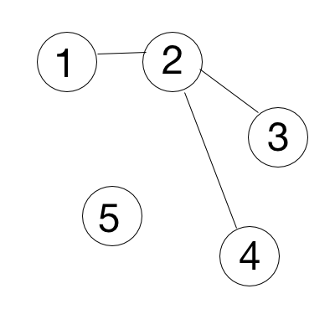
- Roads Count. You need to print out a count of roads by given adjacency matrix. Input: 1st row - N, number of cities, next N rows - adjacency matrix.
Input: Output:
5 3
0 1 0 0 0
1 0 1 1 0
0 1 0 0 0
0 1 0 0 0
0 0 0 0 0

Solution:
Questions to discuss: 1. Oriented vs not oriented -> is symmetric matrix or not. 2. How does matrix change If there are several roads between cities(a[i][j] = 3 or a[1][1] = 5)
Not oriented graph: count all values and divide by 2. Oriented graph: count all values
def roadcount(a):
res = 0
for i in range(len(a)):
for k in range(len(b)):
res += a[i][k]
res = res / 2 # in case of not oriented graph
return res

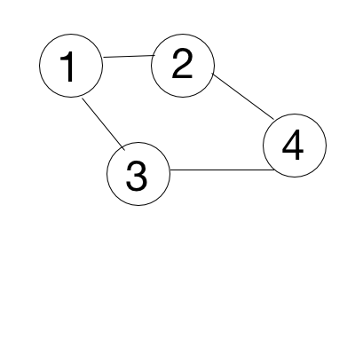
- Find a ring road. You need to print “Ring road” if there are roads that make a ring road, “Tree structure” - otherwise. Input: 1st row - N, number of cities, next N rows - adjacency matrix.
Input: Output: Input: Output:
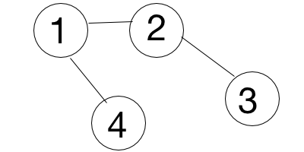
4 Ring road 4 Tree structure
1 1 1 0 1 0 1 1
1 1 0 1 0 1 0 0
1 0 1 1 1 0 1 0
0 1 1 1 1 0 0 1

Solution:
Questions to discuss: Are all cities connected?
You need to traverse through a graph by DFS (Depth First Search). If you find a vertex that you’ve already seen - there is a loop.
def find_loop(a, v, seen):
if v in seen:
return true
seen.append(v)
hasLoop = False
for i in a[v]:
hasLoop = hasLoop OR find_loop(a, i, seen)
if hasLoop:
break
return hasLoop

def solve(a, N):
seen = []
for i in range(N):
if i not in seen:
hasLoop = find_loop(a, i, seen)
if hasLoop:
print “Ring Road”
return
print “Tree structure”

- Is there another country? If two cities are connected, they belong to the same country. You need to check if there is only one country on a planet. Print YES - if only one, NO - otherwise. Input: 1st row - N, K, where N - number of cities, K - number of roads, next K rows - adjacency list.
Input: Output: Input: Output: Input: Output:
5 4 YES 1 0 YES 5 2 NO
1 2 1 2
3 4 4 5
5 2
4 5
Solution:
Questions to discuss: In which cases adjacency list is better then adjacency matrix. What is difference between BFS and DFS? What is a connected component?
Traverse with BFS and then compare count of all seen vertices with N. If they are not equal - there is more then 1 connected component

- [DP] The Fibonacci numbers. Write a function that returns $F_{n}$.
In mathematical terms, the sequence Fn of Fibonacci numbers is defined by the recurrence relation with seed values $F_{n}= F_{n-1}+F_{n-2}$ with $F_{0}= 0$ and $F_{1}= 1.$
0, 1, 1, 2, 3, 5, 8, 13, 21, 34, 55, 89, 141, ……..
Input: 3 Output: 2 Input: 10 Ouput: 55
Solution:
Method 1 (Use recursion)
A simple method that is a direct recursive implementation mathematical recurrence relation given above. Time Complexity: T(n) = T(n-1) + T(n-2) which is exponential.
#include<stdio.h>
int fib(int n)
{
if (n <= 1)
return n;
return fib(n-1) + fib(n-2);
}
We can observe that this implementation does a lot of repeated work (see the following recursion tree). So this is a bad implementation for nth Fibonacci number.
fib(5)
/ \
fib(4) fib(3)
/ \ / \
fib(3) fib(2) fib(2) fib(1)
/ \ / \ / \
fib(2) fib(1) fib(1) fib(0) fib(1) fib(0)
/ \
fib(1) fib(0)
Extra Space: O(n) if we consider the function call stack size, otherwise O(1).

Method 2 (Use Dynamic Programming)
We can avoid the repeated work done is the method 1 by storing the Fibonacci numbers calculated so far.
#include<stdio.h>
int fib(int n)
{
/* Declare an array to store fibonacci numbers. */
int f[n+1];
int i;
/* 0th and 1st number of the series are 0 and 1*/
f[0] = 0;
f[1] = 1;
for (i = 2; i <= n; i++)
{
/* Add the previous 2 numbers in the series and store it */
f[i] = f[i-1] + f[i-2];
}
return f[n];
}
Time Complexity: O(n)
Extra Space: O(n)

Method 3 (Space Optimized Method 2)
We can optimize the space used in method 2 by storing the previous two numbers only because that is all we need to get the next Fibonacci number in series.

#include<stdio.h>
int fib(int n)
{
int a = 0, b = 1, c, i;
if( n == 0)
return a;
for (i = 2; i <= n; i++)
{
c = a + b;
a = b;
b = c;
}
return b;
}

Time Complexity: O(n) Extra Space: O(1)

- [DP] Making change. Given an infinite number of quarters (25 cents), dimes (10 cents), nickels (5 cents) and pennies (1 cent). Write a code to calculate the number of ways of representing n cents.
Input: 3 Output: 1 (1+1+1) Input: 10 Output: 4 (10, 5+5, 5+1+1+1+1+1, 1+1+..+1+1)
Solution:
Solution (recursive one from “Cracking the Code interview”)
public static int makeChange(int n, int denom) {
int next_denom = 0;
switch (denom) {
case 25:
next_denom = 10;
break;
case 10:
next_denom = 5;
break;
case 5:
next_denom = 1;
break;
case 1:
return 1;
}

int ways = 0;
for(int i=0; i*denom<=n; i++) {
ways += makeChange(n - i * denom, next_denom);
}
return ways;
}

System.out.writeln(makeChange(n, 25));
- [DP] Maximum Subarray. Find the contiguous subarray within an array (containing at least one number) which has the largest sum.
Input: [−2,1,−3,4,−1,2,1,−5,4] Output: 6 ([4,−1,2,1])
Solution:
http://people.cs.clemson.edu/~bcdean/dp_practice/dp_1.swf
http://www.programcreek.com/2013/02/leetcode-maximum-subarray-java/

Graph, DP. Advanced

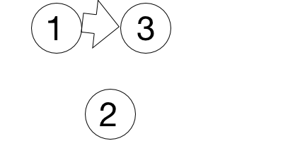
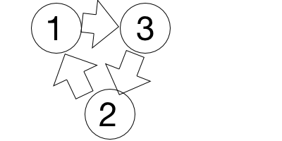
- Find a ring road. Some of those roads are one way roads. You need to print “Ring road” if there are roads that make a ring road, “Tree structure” - otherwise. Input: 1st row - N, number of cities, next N rows - adjacency matrix.
Input: Output: Input: Output:
3 Ring road 4 Tree structure
1 0 1 1 0 1 1
1 1 0 0 1 0 0
0 1 1 0 0 1 0
0 0 0 1

Questions to discuss: Are all cities connected?
Solution: traverse through a graph by DFS (Depth First Search). If you find a vertex that you’ve already seen - there is a loop.
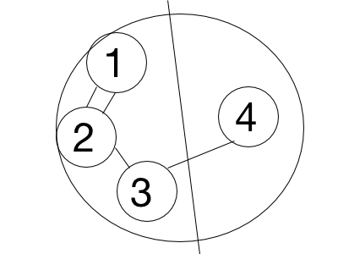
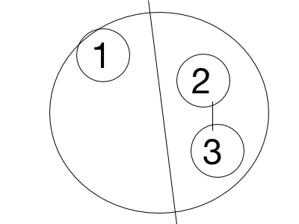
- Path from near side to far side. Some of those cities are on the near side of Neptune, others are on the far side. Print ”YES” if there is a path from the near side to the far side, otherwise - “NO”. Input: 1st row - N, M, K, where N - total number of cities, M - number of cities on the rear side, K - number of roads, 2nd row - K cities from the rear side, next K rows - adjacency list.
Input: Output: Input: Output:
5 4 3 <- 5 vertices, 4 roads. 3 vertices on a near side YES 3 1 1 NO
1 2 3 <- 3 vertices on a near side 1
1 2 2 3
2 1
2 3
3 4
Solution: for each vertex from near side find connected component that it belongs to. If some component has vertices from both sides - there is a way.
Optimization: while looking for connected components - check if all vertices from the same side. if not - found a way and you can stop.
Questions to discuss: What is a connected component? What is difference between BFS and DFS? When adjacency list is better to use than matrix?
- Is there another country? If two cities are connected, they belong to the same country. You need to print all cities for each country. Input: 1st row - N, K, where N - number of cities, K - number of roads, next K rows - adjacency list.
Input: Output: Input: Output: Input: Output:
5 3 1 2 5 1 0 1 5 2 1 2
1 2 3 4 1 2 3
3 4 4 5 4 5
5 2
Questions to discuss: What is a connected component? What is difference between BFS and DFS? When adjacency list is better to use than matrix?
Solution: find all connected components by DFS/BFS. Print all vertices for each component.
- [DP] Fibonacci Modified. A series is defined in the following manner:Given the nth and (n+1)th terms, the (n+2)th can be computed by the following relation T_{n+2} = (T_{n+1})² + T_{n}
So, if the first two terms of the series are 0 and 1: T₃ = 12 + 0 = 1 T₄ = 12 + 1 = 2 T₅ = 22 + 1 = 5.
Given three integers A, B and N, such that the first two terms of the series (1st and 2nd terms) are A and B respectively, compute the Nth term of the series.
Input: 0 1 5 Output: 5
- [DP] Minimum Number of Coins. Given a list of N coins, their values (V₁, V₂, ... , V_{N}), and the total sum S. Find the minimum number of coins the sum of which is S (we can use as many coins of one type as we want), or report that it's not possible to select coins in such a way that they sum up to S.
Input: Input:
5 10 5 3
1 1 1 1 2 1 2 3
Output: Output:
0 1
- [DP] Bricks Game. You and your friend decide to play a game using a stack consisting of N bricks. In this game, you can alternatively remove 1, 2 or 3 bricks from the top, and the numbers etched on the removed bricks are added to your score. You have to play so that you obtain the maximum possible score. It is given that your friend will also play optimally and you make the first move. Input: first line will contain a number N i.e. number of elements in the stack and next line will contain N numbers i.e. numbers etched on bricks from top to bottom.
5 5
999 1 1 1 0 0 1 1 1 999
Output: 1001 Output: 999
Solution:
Build a table for i from 1 to N such as for a[i] you define max sum and which number of bricks you need to grab.
Example: 10 1 1 1 1 10

value | 10 | 1 | 1 | 1 | 1 | 10
max Sum | 10 | 11 | 12 | 3 | 11 | 21
num of bricks to grab | 1 | 2 | 3 | 3 | 1 | 2

for i - from 0 to N:
s1 -> a[i].value + a[i - a[i-1].num].sum
s2 -> a[i].value + a[i-1].value + a[a[i - 2].num].sum
s3 -> a[i].value + a[i - 1].value + a[i-2].value + a[a[i-3]].sum
a[i]. sum = max(s1,s2,s3)
a[i].num = 1 vs 2 vs 3 depending on a[i]. sum

